Software Design Document
UniEvent 360 – Smart Multi-Tiered Event Management & Digital Ticketing System



Submitted by
Ahmer Ali (S23BINFT1M01017)

Submitted to
Sir Wahaj Ali

Department of Information Technology
Faculty of Computing
The Islamia University of Bahawalpur

Summary
This Software Design Document describes the internal design and architecture of UniEvent 360 – Smart Multi-Tiered Event Management & Digital Ticketing System. The purpose of this system is to digitize and centralize university event management by providing a secure platform for students, organizers, volunteers, and administrators. The system manages event creation, ticket booking, attendance verification, notifications, and navigation through a single integrated platform.
The system is built using Flutter as the frontend framework, Firebase as the backend platform, Cloud Firestore as the database, and Firebase Authentication for user management. Google Maps API provides location-based navigation, while JazzCash, EasyPaisa, and bank card integrations support secure online payments. UUID-based QR encryption is used to ensure secure ticket validation and fraud prevention.
This document covers the complete application architecture, explains the proposed controllers and their functions, and describes how the system components interact with each other. The data model section defines the database tables, their attributes, and relationships. The user interface section documents the design philosophy, major screens, controls, and input constraints used throughout the application.
All required UML diagrams have been included in the relevant sections: System Context Diagram, DFD Level 0 and Level 1, Sequence Diagram, Activity Diagram, Component Diagram, Class Diagram, ER Diagram, and Use Case Diagram.

Table of Content
1. Application Architecture ............................................................................................... 1
1.1 Architecture Pattern .................................................................................................... 1
1.2 List of Controllers and Their Functions ..................................................................... 2
1.2.1 AuthController ................................................................................................... 2
1.2.2 TicketController ................................................................................................. 3
1.2.3 PaymentController ............................................................................................. 3
1.2.4 NotificationController ........................................................................................ 4
1.2.5 VolunteerController ........................................................................................... 4
1.2.6 CertificateController .......................................................................................... 5
1.2.7 AdminController ................................................................................................. 5
1.3 External APIs and Libraries ......................................................................................... 6
1.4 Coding Conventions ....................................................................................................... 7
1.5 UML Diagrams ............................................................................................................... 8
1.5.1 System Context Diagram .................................................................................... 8
1.5.2 Data Flow Diagram (Level 0 and Level 1) ........................................................ 8
1.5.3 Sequence Diagram – Event Ticket Booking Process ...................................... .10
1.5.4 Activity Diagram – Full System Workflow ...................................................... 11
1.5.5 Component Diagram .......................................................................................... 13
1.5.6 Class Diagram ...................................................................................................... 13
1.5.7 Use Case Diagram .............................................................................................. 14
2. Data Model Schema ......................................................................................................... 15
2.1 ER Diagram .................................................................................................................... 15
2.2 Table Descriptions .......................................................................................................... 16
2.2.1 Users Collection ................................................................................................... 16
2.2.2 Events Collection ................................................................................................. 17
2.2.3 Bookings Collection ............................................................................................. 18
2.2.4 Tickets Collection ................................................................................................ 18
2.2.5 Payments Collection ............................................................................................ 19
2.2.6 Attendance Collection ......................................................................................... 20
2.2.7 Volunteers Collection .......................................................................................... 21
2.2.8 Certificates Collection ......................................................................................... 22
2.2.9 Notifications Collection ....................................................................................... 23
2.2.10 Waitlist Collection ............................................................................................. 24
3. User Interface ................................................................................................................... 25
3.1 Design Philosophy and Interface Specifications .......................................................... 25
3.1.1 Color Scheme ....................................................................................................... 25
3.1.2 Typography ......................................................................................................... 26
3.1.3 Screen Layout Rules ........................................................................................... 27
3.2 List of Pages and Screen Descriptions ......................................................................... 28
3.2.1 Login Screen ....................................................................................................... 28
3.2.2 Registration Screen ............................................................................................ 29
3.2.3 User Dashboard .................................................................................................. 30
3.2.4 Event Details Screen ........................................................................................... 30
3.2.5 Ticket Booking Screen .................................................................................... 31
3.2.6 Payment Screen ............................................................................................... 31
3.2.7 Digital Ticket Screen ...................................................................................... 32
3.2.8 Organizer Dashboard ..................................................................................... 33
3.2.9 Volunteer Scanner Screen .............................................................................. 33
3.2.10 Administrator Dashboard ............................................................................ 34
3.3 Controls, Input Constraints, and Feedback ............................................................ 34
3.3.1 Input Controls ................................................................................................. 34
3.3.2 Input Constraints ........................................................................................... 36
3.3.3 Error Messages ............................................................................................... 37
3.3.4 Success Messages ............................................................................................ 38
3.3.5 Notifications and Feedback ........................................................................... 39
Appendix A:…………...................................................................................................... 40
References ........................................................................................................................ 42

- Application Architecture

UniEvent 360 follows a client-server architecture using Flutter as the frontend framework and Firebase as the backend platform. This architecture was selected because it provides real-time communication, secure authentication, scalability, and efficient data management. On the frontend, Flutter is responsible for building the mobile application interface and handling user interactions. On the backend, Firebase manages authentication, database operations, notifications, and cloud services. The overall system is divided into four main layers. The Presentation Layer consists of the Flutter mobile application. The Application Layer consists of Firebase services that process requests and execute business logic. The Data Layer contains Cloud Firestore and Firebase Storage for storing application data and media files. The External Services Layer includes Google Maps API for event navigation and payment gateways such as JazzCash, EasyPaisa, and bank card services for secure transaction processing.

1.1 Architecture Pattern

The system uses a client-server architecture. In this project:

Presentation Layer — The Flutter mobile application acts as the presentation layer. It provides all user interfaces including event browsing, ticket booking, QR display, notifications, volunteer scanning, and navigation screens.

Application Layer — Firebase services act as the application layer. Firebase Authentication handles user authentication, Cloud Functions process business logic, and Firebase Cloud Messaging manages notifications.

Data Layer — Cloud Firestore and Firebase Storage store all application data including users, events, tickets, payments, certificates, and media files.

External Services Layer — Google Maps API provides event location and navigation services, while JazzCash, EasyPaisa, and bank card gateways handle secure payment transactions.

This architecture works well for the project because the Flutter frontend and Firebase backend can be developed, tested, and maintained independently while supporting real-time updates and scalable system operations.

1.2 List of Controllers and Their Functions
Below are the main controllers that handle the backend logic of UniEvent 360. Models and Views are not explained here in detail as per the documentation requirements.

AuthController
Handles all authentication-related requests. It manages user registration, login, logout, and role-based access using Firebase Authentication.
Function | Description
store(Request $req) | Creates a new event and stores all event details in the database.
index() | Returns a list of available events for users and organizers.
show($id) | Returns complete details of a selected event.
update(Request $req, $id) | Updates event information including schedule, venue, and ticket settings.
destroy($id) | Removes or archives an event from the system.
validateSchedule(Request $req) | Checks venue availability and prevents scheduling conflicts.

Ticket Controller
Handles all ticket-related operations including ticket booking, inventory management, waitlist processing, and QR ticket generation.
Function | Description
bookTicket(Request $req) | Creates a ticket booking record for a selected event.
checkAvailability($eventId) | Returns the number of available tickets for the selected event.
generateQRCode($ticketId) | Generates a unique encrypted QR code for the ticket.
joinWaitlist(Request $req) | Adds a user to the waitlist when tickets are sold out.
cancelBooking($id) | Cancels a ticket booking and updates ticket inventory.

PaymentController
Manages all payment-related transactions and financial operations.
Function | Description
processPayment(Request $req) | Processes ticket payments through supported payment gateways.
verifyPayment($transactionId) | Verifies transaction status and confirms payment.
refundPayment(Request $req) | Processes ticket refunds if refunds are enabled for the event.
paymentHistory($userId) | Returns the payment history of a user.

NotificationController
Handles all notification and alert services within the system.
Function | Description
sendNotification(Request $req) | Sends notifications to selected users.
sendReminder($eventId) | Sends automated event reminders before the event starts.
notifyWaitlist($eventId) | Notifies waitlisted users when tickets become available.
computeCodeQualityScore() | Checks the submitted code for syntax errors, cyclomatic complexity, and readability indicators. Weighted at 20%.
sendAnnouncement(Request $req) | Sends event-related announcements and updates.

VolunteerController
Manages volunteer assignments, attendance tracking, and QR ticket scanning operations during events.
Function | Description
assignVolunteer(Request $req) | Assigns volunteers to a specific event.
scanTicket(Request $req) | Scans and validates QR tickets at the event venue.
markAttendance($ticketId) | Marks attendee entry after successful ticket verification.
trackPerformance($volunteerId) | Records volunteer check-in and check-out activities.

CertificateController
Handles certificate generation and distribution for event participants.
Function | Description
generateCertificate($eventId) | Generates certificates for eligible attendees.
verifyAttendance($eventId)
  Verifies attendance records before certificate generation.
sendCertificate($userId)
  Delivers certificates to users through the system.
downloadCertificate($certificateId)
  Allows users to download their certificates.

AdminController
Provides administrators with access to user management, event monitoring, reporting, and system-level operations.
Function | Description
listUsers() | Returns all registered users in the system.
updateUser(Request $req, $id) | Updates user information, roles, or account status.
manageEvents() | Monitors and manages all events across the platform.
generateSystemReport() | Generates system-wide reports and analytics.
deactivateAccount($id) | Disables user accounts when necessary.

1.3 External APIs and Libraries
The following external APIs and libraries are used by the system:
Name | Layer | How it is used
Firebase Authentication | Backend | Handles user registration, login, password management, and role-based authentication for Students, Organizers, Volunteers, and Administrators.
Cloud Firestore | Database | Stores all application data including users, events, tickets, payments, notifications, certificates, and attendance records.
Firebase Cloud Messaging (FCM) | Backend | Sends push notifications, event reminders, announcements, and waitlist alerts to users.
Firebase Storage | Backend | Stores event images, QR tickets, certificates, and other uploaded files.
Google Maps API | External Service | Provides event location display, map integration, and navigation from the user's current location to the event venue.
JazzCash API | Payment Gateway | Processes secure online ticket payments through JazzCash accounts.
EasyPaisa API | Payment Gateway | Enables ticket payments using EasyPaisa services.
QR Code Generator Library | Security | Generates encrypted UUID-based QR codes for digital tickets and attendance verification.
Flutter Google Maps Package | Frontend | Integrates Google Maps functionality directly into the Flutter application.
Flutter Local Notifications | Frontend | Displays local reminders and notification alerts on user devices.
Flutter Material Design Library | Frontend | Provides UI components and design elements used throughout the application.

1.4 Coding Conventions
- Flutter follows Dart coding standards throughout the application.
- Controller, Service, Model, and Screen class names use PascalCase (e.g., EventController, PaymentService, UserModel).
- All function and variable names use camelCase (e.g., createEvent(), processPayment(), userLocation).
- Database collection names use snake_case (e.g., users, event_bookings, attendance_logs).
- Flutter screens are organized by feature in separate folders (e.g., /screens/events, /screens/tickets, /screens/admin).
- Firebase Cloud Functions are organized according to system modules such as authentication, events, payments, and notifications.
- All API responses follow a standard JSON format: { status, message, data }.
- Environment variables, API keys, database credentials, and payment gateway secrets are stored securely and never hardcoded in the application.
- UUID-based QR codes are generated using standardized encryption methods to ensure ticket uniqueness and prevent duplication.

Role-Based Access Control (RBAC) is applied throughout the system to ensure that users can only access features permitted by their assigned roles.

1.5 UML Diagrams

1.5.1 System Context Diagram
The System Context Diagram below shows UniEvent 360 as the central system. On one side, the four types of users interact with it: Student/User, Organizer, Volunteer, and Administrator. On the other side, the system communicates with external services including Google Maps API, JazzCash, EasyPaisa, and Firebase Cloud Messaging (FCM). Cloud Firestore and Firebase Storage are part of the system boundary. The Flutter frontend and Firebase backend are both
inside the system rectangle.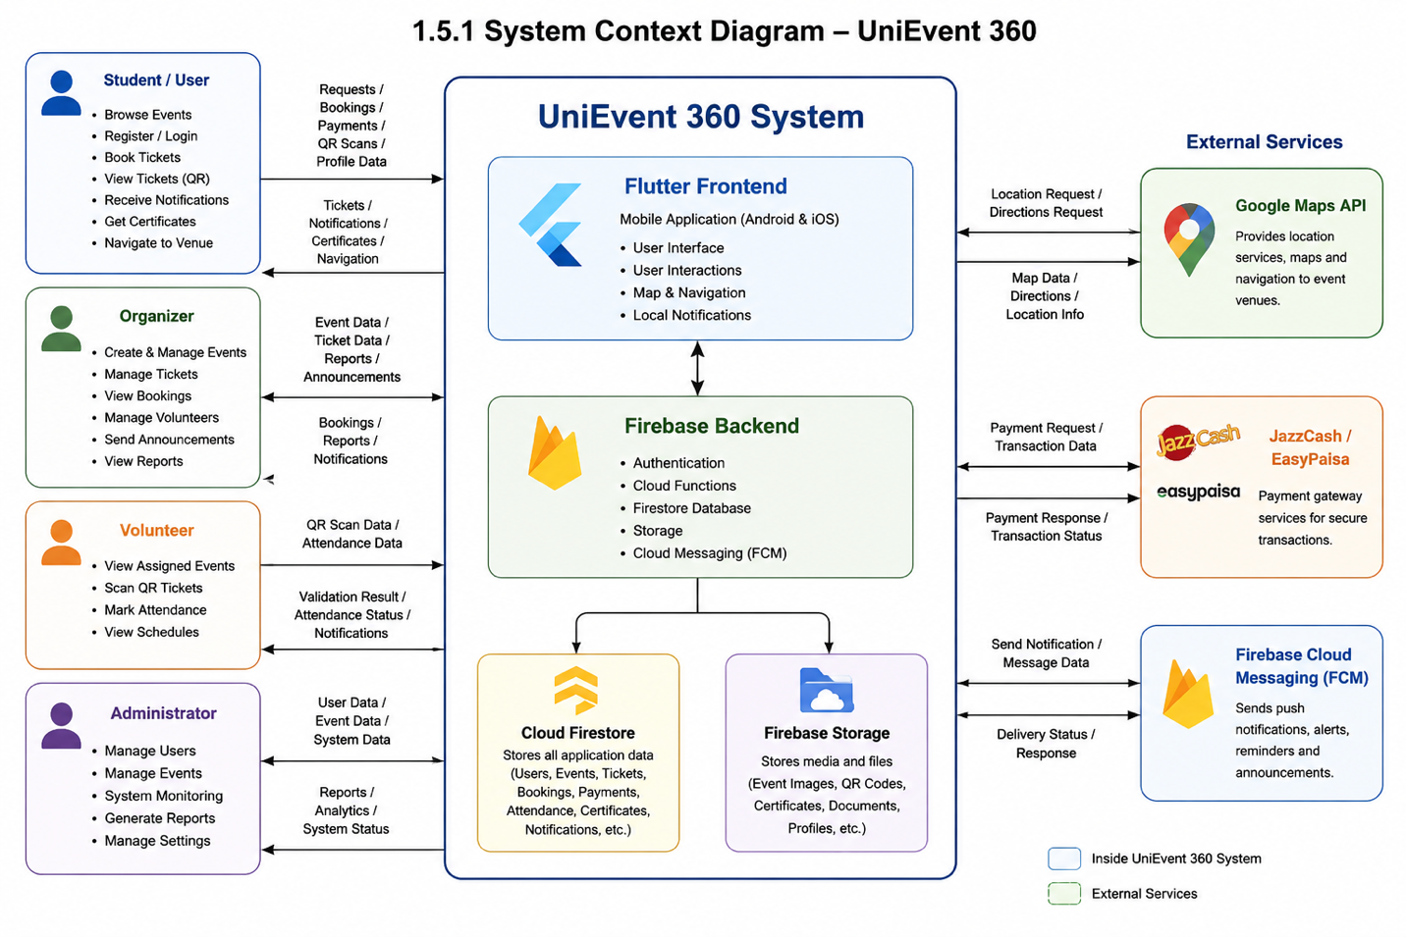

1.5.2 Data Flow Diagram (Level 0 and Level 1)
The DFD is provided at two levels. Level 0 shows the whole system as a single process that receives inputs from users including registration data, event details, booking requests, payments, and QR scans, and returns outputs such as tickets, notifications, certificates, reports, and navigation information.
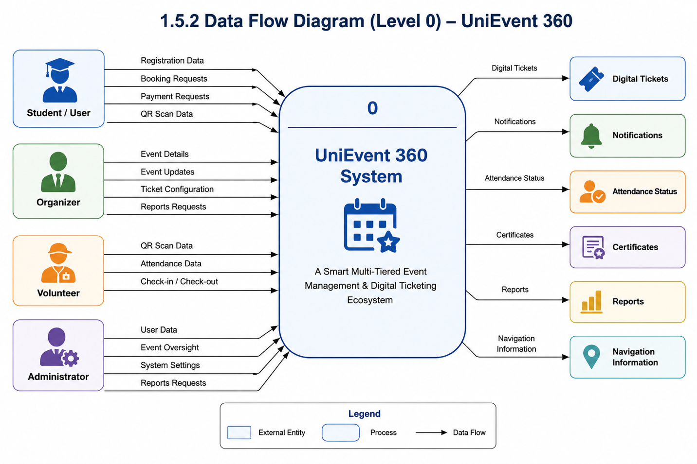
Level 1 breaks that single process into six sub-processes: User Authentication, Event Management, Ticket Management, Payment Processing, Attendance Verification, and Notification Services.

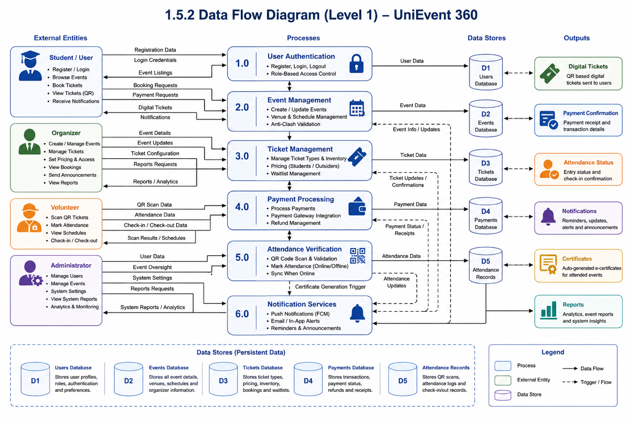

1.5.3 Sequence Diagram — Event Ticket Booking Process
The Sequence Diagram below shows what happens from the moment a user selects an event until a ticket is successfully booked. Solid arrows represent requests and dashed arrows represent return messages. The main participants are User, Flutter Application, Firebase Services, Payment Gateway, and Cloud Firestore.
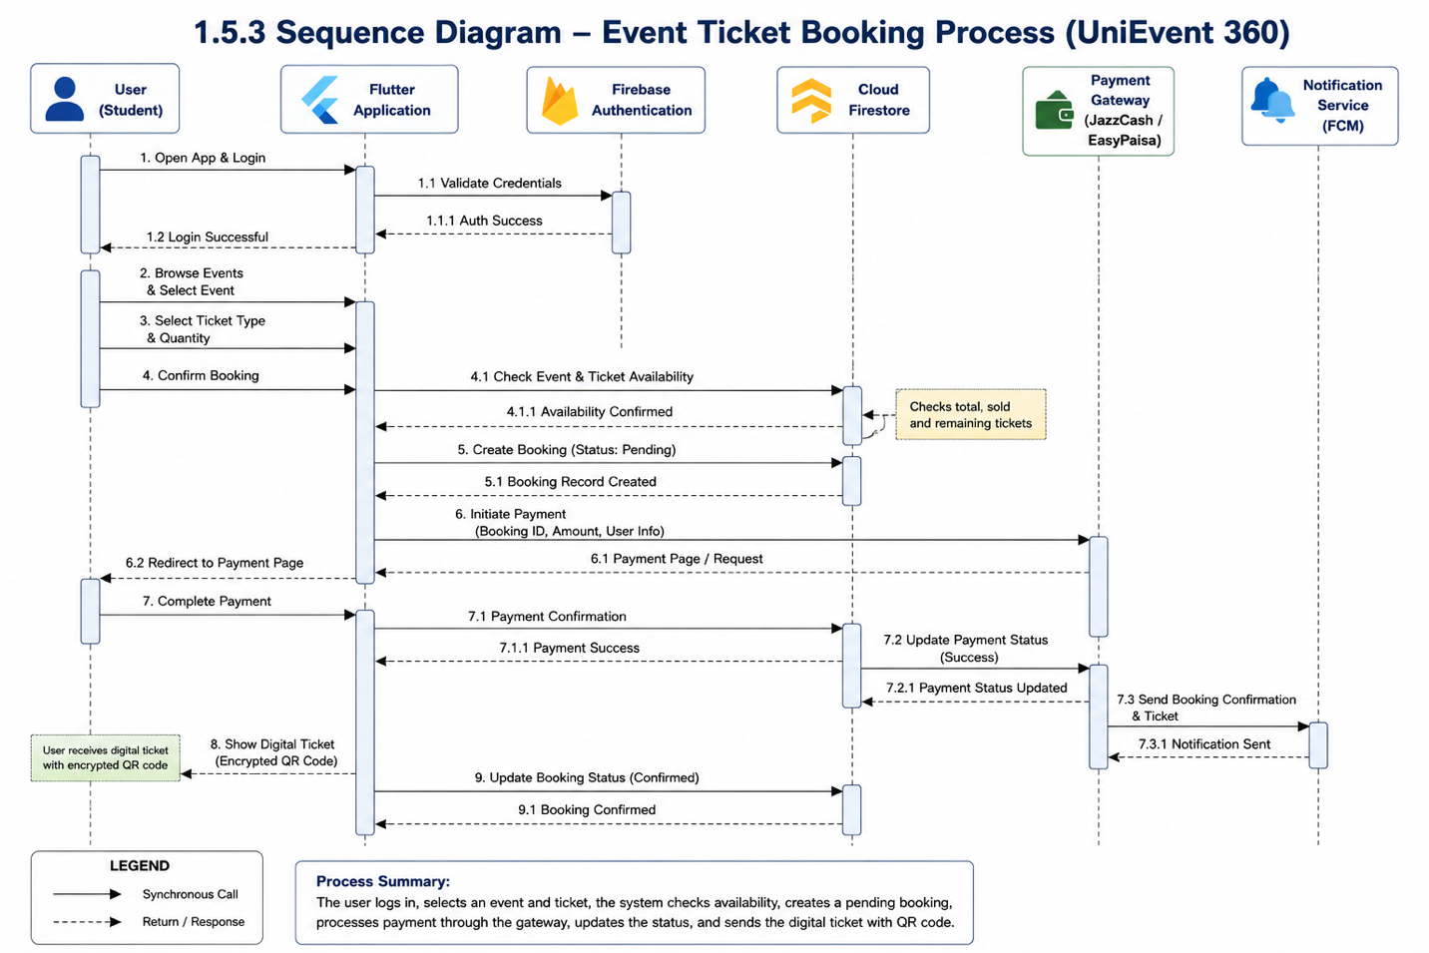

1.5.4 Activity Diagram — Full System Workflow
The Activity Diagram covers the complete control flow of the system from user registration to event participation and certificate generation. Decision diamonds show major branching points such as ticket availability, payment success, QR validation status, and certificate eligibility.

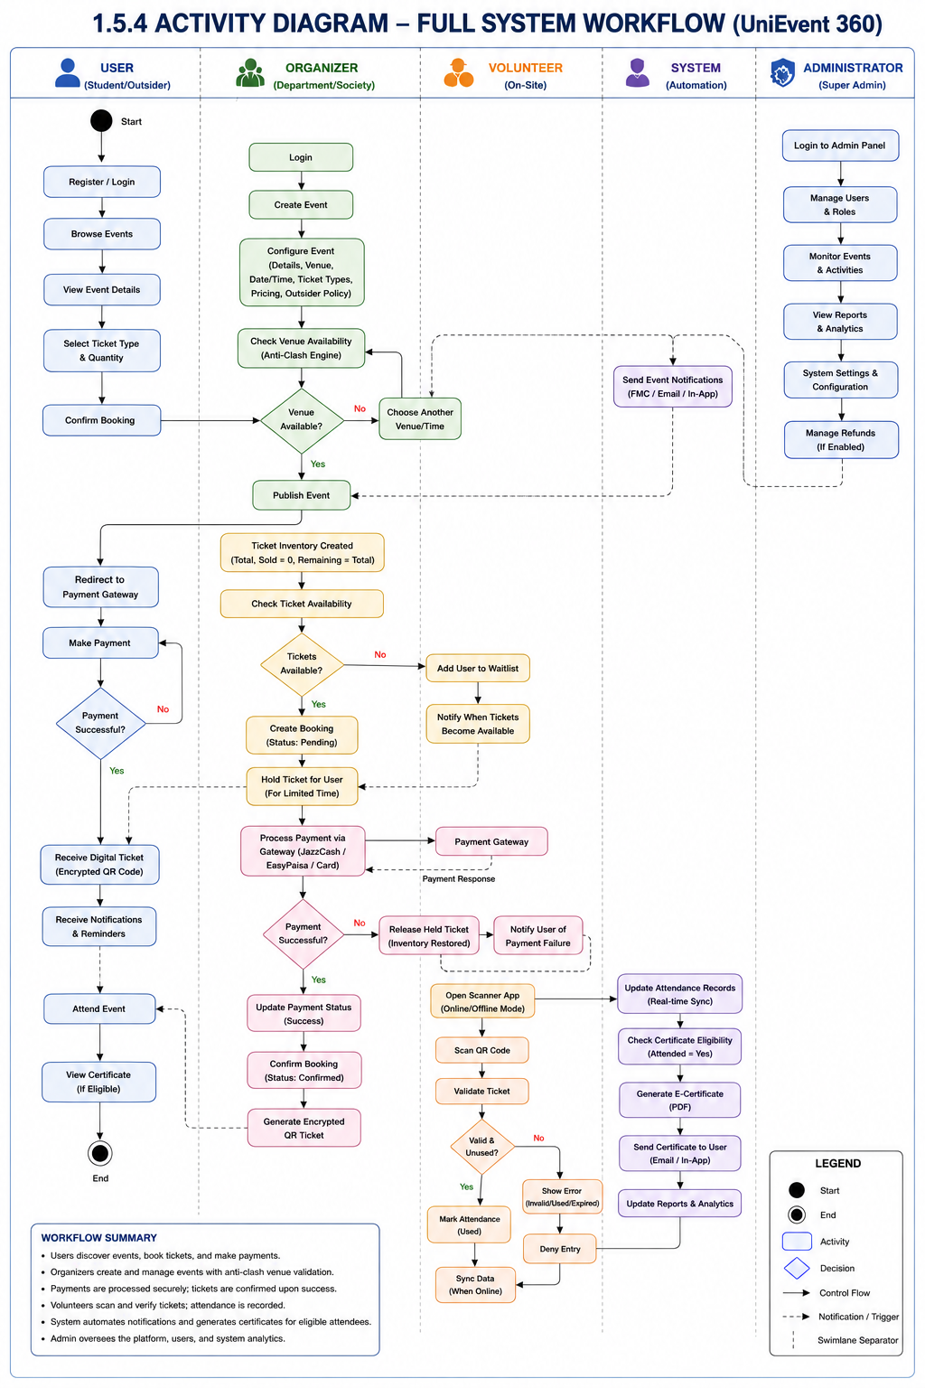

1.5.5 Component Diagram
The Component Diagram shows how the major parts of the system are organized and how they depend on each other. There are three main subsystems: the Flutter Presentation Layer, the Firebase Application Layer, and the External Services Layer. Arrows show the direction of calls and data flow between components.

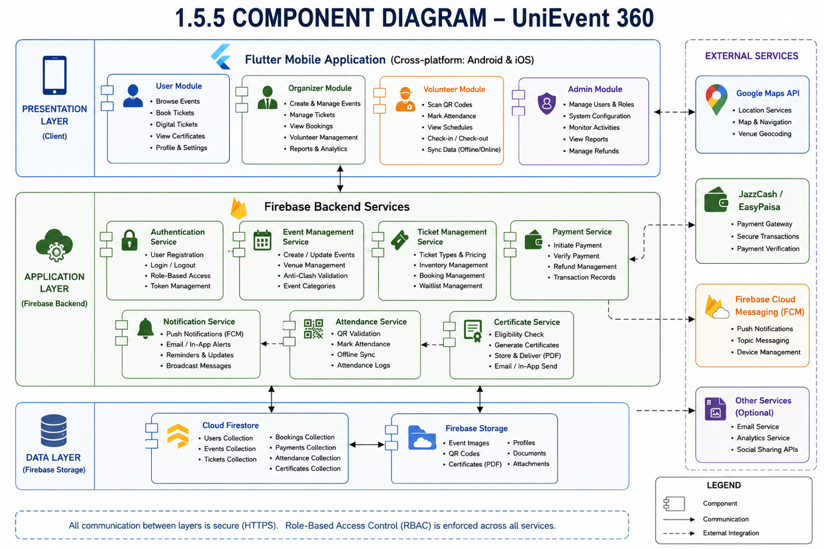

1.5.6 Class Diagram

The Class Diagram below shows the main classes in the system along with their attributes, methods, and relationships. The primary relationships shown are: User books Ticket, Organizer manages Event, Event generates Tickets, Volunteer verifies Attendance, and System generates Certificates.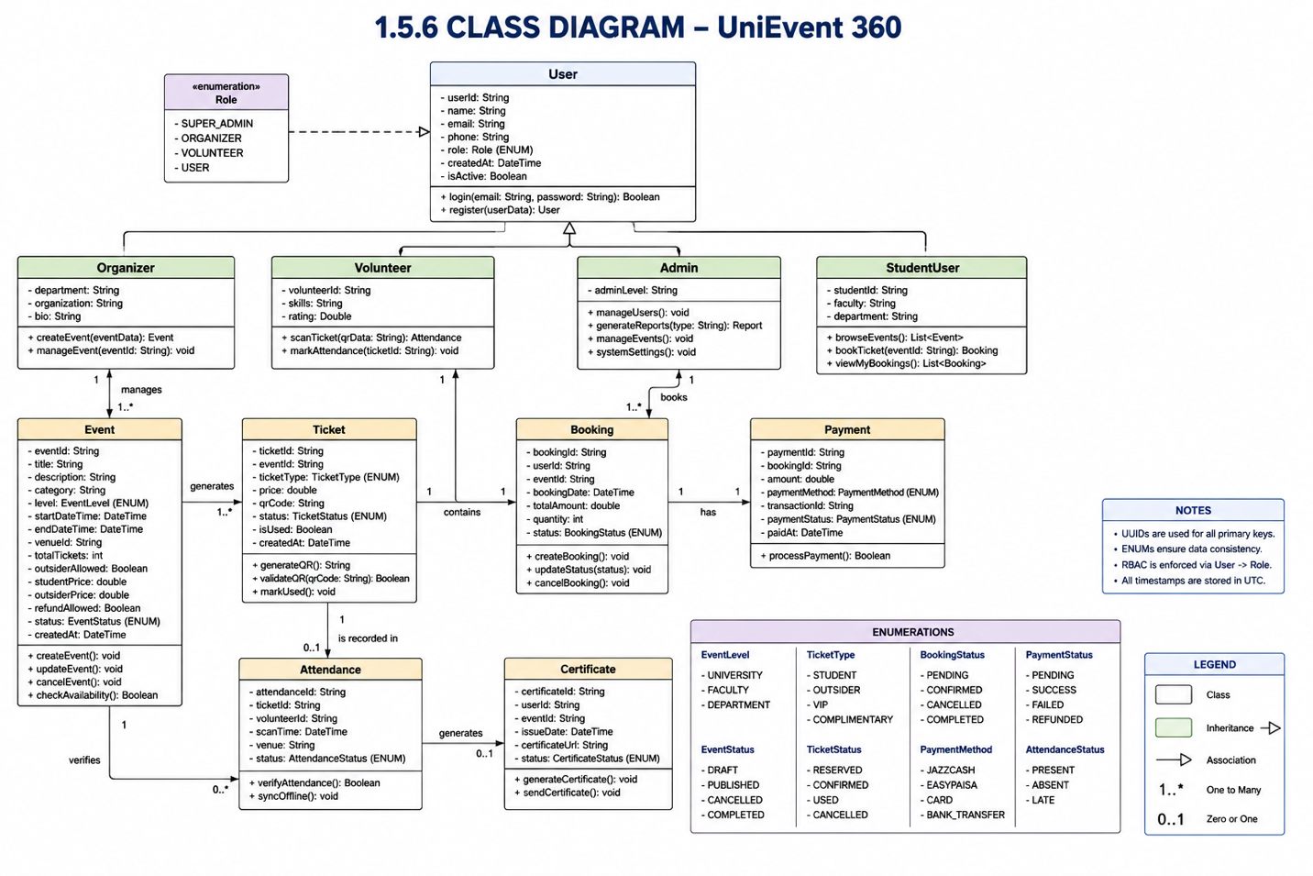

1.5.7 Use Case Diagram
The Use Case Diagram below shows all major use cases of the system and which actors can trigger them. The four actors are Student/User, Organizer, Volunteer, and Administrator. The system also acts as its own actor for automated processes such as notifications, waitlist handling, and certificate generation. Include and extend relationships are shown where one use case always triggers another, or where something happens only under specific conditions.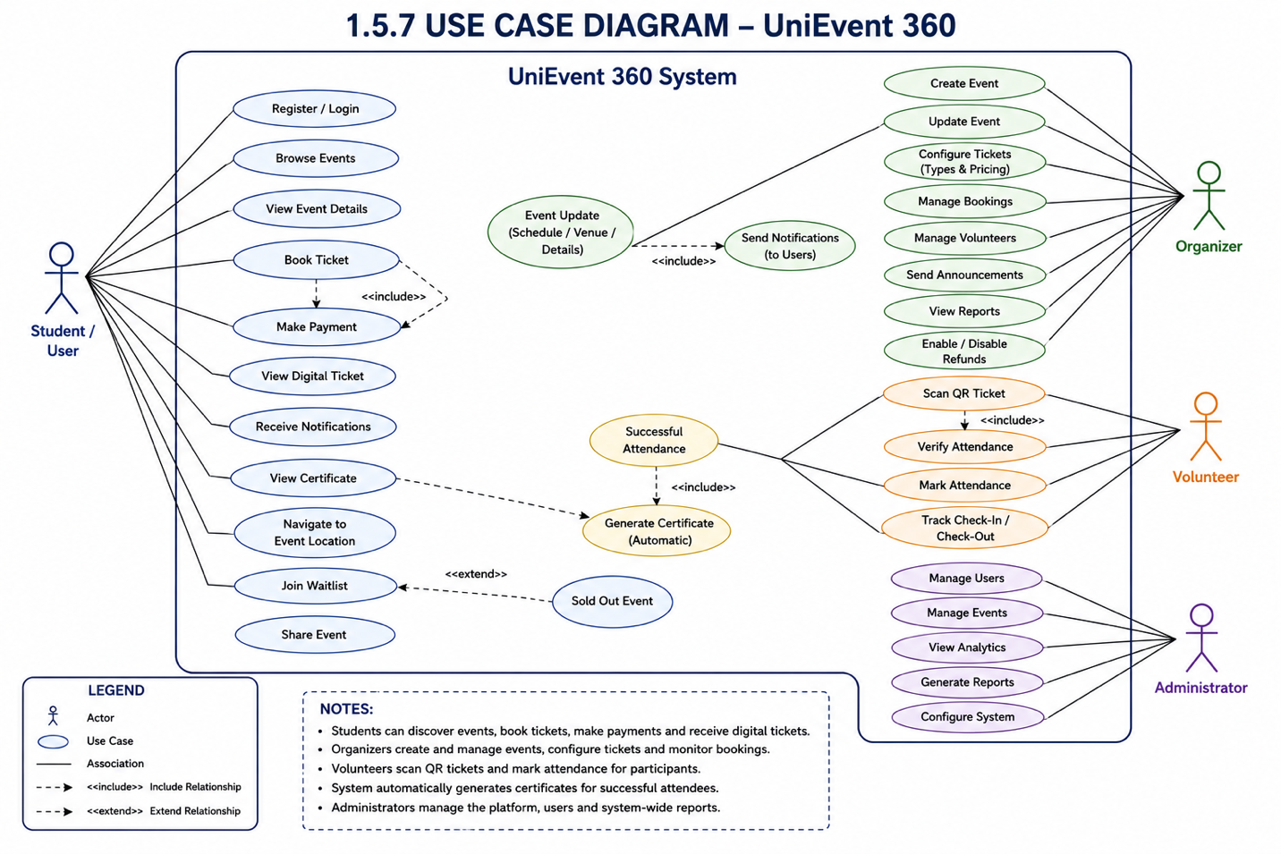
- Data Model Schema

The data model defines how information is stored, managed, and related within the UniEvent 360 system. Cloud Firestore serves as the primary database and stores data in collections and documents. The schema is designed to support event management, ticket booking, attendance verification, payment processing, volunteer management, certificate generation, and notification services. Relationships between collections ensure data consistency and efficient retrieval of information across the platform.

2.1 ER Diagram
The ER Diagram illustrates the relationships among the major entities of the system. The primary entities include User, Event, Booking, Ticket, Payment, Attendance, Volunteer, Notification, and Certificate. These entities work together to support event management, ticketing, attendance verification, and system administration.
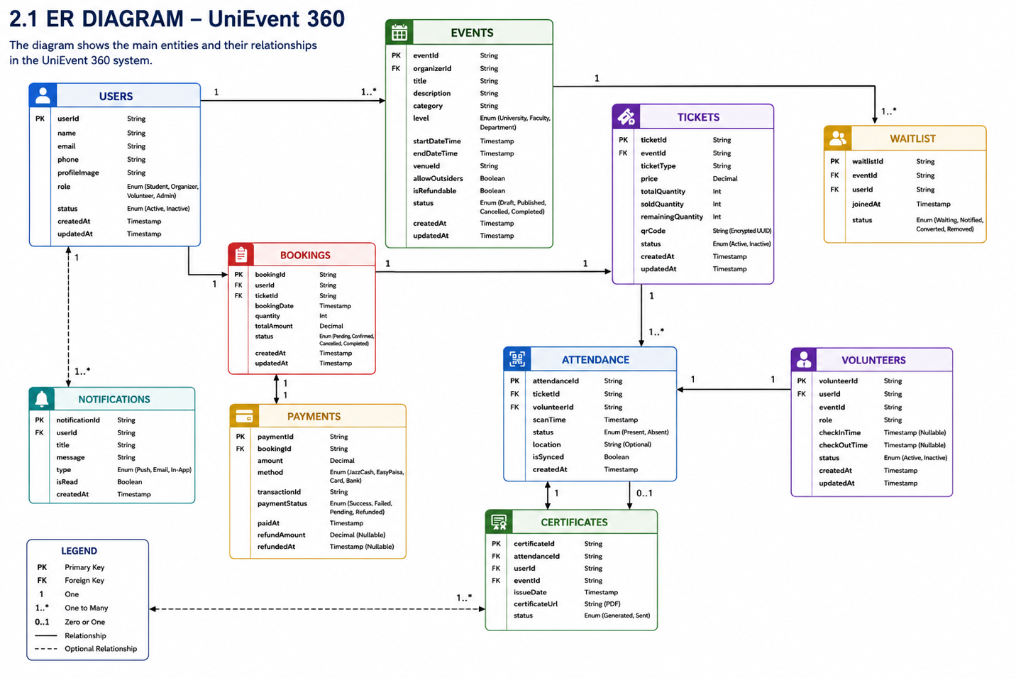

2.2 Table Descriptions

2.2.1 Users Collection
This collection stores information about all registered users of the system, including Students, Organizers, Volunteers, and Administrators.
Column | Type | Description
userId | String | Unique identifier of the user
name | String | Full name of the user
email | String | User email address
phone | String | Contact number
role | String | Student, Organizer, Volunteer, Admin
profileImage | String | User profile image URL
status | Boolean | Active or inactive account
createdAt | Timestamp | Account creation date
  updatedAt
  Timestamp
  Last profile update date

2.2.2 Events Collection
This collection stores all event-related information created by organizers.
Column | Type | Description
eventId | String | Unique event identifier
organizerId | String | Organizer responsible for the event
title | String | Event title
description | String | Event description
category | String | Event category
level | String | University, Faculty, Department
venue | String | Event location
startDateTime | Timestamp | Event start date and time
endDateTime | Timestamp | Event ending date and time
allowOutsiders | Boolean | Outsider access status
refundAllowed | Boolean | Refund policy status
status | String | Draft, Published, Cancelled, Completed
createdAt | Timestamp | Event creation date

2.2.3 Bookings Collection
This collection stores ticket booking information.
Column | Type | Description
bookingId | String | Unique booking identifier
userId | String | User who booked the ticket
ticketId | String | Associated ticket
bookingDate | Timestamp | Date of booking
quantity | Integer | Number of tickets booked
totalAmount | Decimal | Total payment amount
status | String | Pending, Confirmed, Cancelled
createdAt | Timestamp | Booking creation date

2.2.4 Tickets Collection
This collection stores ticket inventory and QR information.
Field Name | Data Type | Description
ticketId | String | Unique ticket identifier
eventId | String | Associated event
ticketType | String | Student, Outsider, VIP
price | Decimal | Ticket price
totalQuantity | Integer | Total available tickets
soldQuantity | Integer | Number of sold tickets
remainingQuantity | Integer | Remaining tickets
qrCode | String | Encrypted UUID QR code
status | String | Active, Used, Cancelled
createdAt | Timestamp | Ticket creation date

2.2.5 Payments Collection
This collection stores all transaction and payment-related information generated during ticket purchases.
Field Name | Data Type | Description
paymentId | String | Unique payment identifier
bookingId | String | Associated booking
amount | Decimal | Payment amount
method | String | JazzCash, EasyPaisa, Bank Card
transactionId | String | Gateway transaction reference
paymentStatus | String | Pending, Success, Failed, Refunded
paidAt | Timestamp | Payment completion time
refundAmount | Decimal | Refunded amount
refundDate | Timestamp | Refund processing date

2.2.6 Attendance Collection
This collection stores attendance records generated after QR ticket verification.
Field Name | Data Type | Description
attendanceId | String | Unique attendance identifier
ticketId | String | Associated ticket
volunteerId | String | Volunteer who scanned the ticket
scanTime | Timestamp | Time of QR scan
status | String | Present, Absent
location | String | Attendance verification location
isSynced | Boolean | Offline synchronization status
createdAt | Timestamp | Attendance record creation date

2.2.7 Volunteers Collection
This collection stores volunteer assignments and performance information.
Field Name | Data Type | Description
volunteerId | String | Unique volunteer identifier
userId | String | Associated user account
eventId | String | Assigned event
role | String | Volunteer responsibility
checkInTime | Timestamp | Volunteer check-in time
checkOutTime | Timestamp | Volunteer check-out time
status | String | Active, Inactive
createdAt | Timestamp | Record creation date

2.2.8 Certificates Collection
This collection stores certificates generated for eligible event participants.
Field Name | Data Type | Description
certificateId | String | Unique certificate identifier
attendanceId | String | Associated attendance record
userId | String | Certificate owner
eventId | String | Related event
issueDate | Timestamp | Certificate generation date
certificateUrl | String | PDF certificate location
status | String | Generated, Sent

2.2.9 Notifications Collection
This collection stores notification messages and delivery information.
Field Name | Data Type | Description
notificationId | String | Unique notification identifier
userId | String | Notification recipient
title | String | Notification title
message | String | Notification content
type | String | Push, Email, In-App
isRead | Boolean | Read status
createdAt | Timestamp | Notification creation date

2.2.10 Waitlist Collection
This collection stores users waiting for ticket availability when an event is sold out.
Field Name | Data Type | Description
waitlistId | String | Unique waitlist identifier
eventId | String | Associated event
userId | String | Waiting user
joinedAt | Timestamp | Waitlist joining date
status | String | Waiting, Notified, Converted, Removed

End of Data Model Schema
The above collections define the complete database structure of UniEvent 360. The schema supports user management, event scheduling, ticket booking, payment processing, attendance verification, volunteer management, certificate generation, notifications, and waitlist operations while maintaining data integrity and efficient retrieval of information throughout the system.

- User Interface

3.1 Design Philosophy and Interface Specifications
The UniEvent 360 interface is designed to provide a simple, responsive, and user-friendly experience for Students, Organizers, Volunteers, and Administrators. The system follows Flutter Material Design standards and maintains a consistent layout across all screens. Navigation is role-based, ensuring users can access only the functions relevant to their responsibilities. The interface is optimized for mobile devices and supports different screen sizes while maintaining usability and accessibility.

3.1.1 Color Scheme
The UniEvent 360 application follows a modern and consistent color scheme to provide a professional user experience. Colors are selected to improve readability, usability, and visual consistency across all screens.
Interface Element | Color
Primary Color | Dark Blue (#1565C0)
Secondary Color | Light Blue (#42A5F5)
Background Color | White (#FFFFFF)
Text Color | Dark Gray (#212121)
Success Messages | Green (#4CAF50)
Warning Messages | Orange (#FF9800)
Error Messages | Red (#F44336)
Buttons | Blue (#1565C0)
Navigation Bar | Dark Blue (#1565C0)
Card Background | Light Gray (#F5F5F5)

3.1.2 Typography

The typography used in UniEvent 360 is selected to ensure readability, consistency, and a professional appearance across all screens. The application follows Material Design typography guidelines provided by Flutter.
consistency across all screens.
Element | Font Style | Size
Main Heading | Bold | 24 px
Section Heading | Semi-Bold | 20 px
Sub Heading | Medium | 18 px
Body Text | Regular | 14 px
Button Text | Medium | 14 px
Labels | Regular | 12 px
Notifications | Regular | 12 px

The typography hierarchy helps users easily distinguish between headings, content, actions, and notifications while maintaining a clean and user-friendly interface throughout the application.

3.1.3 Screen Layout Rules

The screen layouts of UniEvent 360 follow a consistent structure to ensure usability, accessibility, and visual uniformity across the application.
Rule ID | Description
SLR-01 | All screens must display a consistent application header containing the page title.
SLR-02 | Navigation controls must remain in fixed positions throughout the application.
SLR-03 | Forms must display labels above their corresponding input fields.
SLR-04 | Required fields must be clearly indicated to users.
SLR-05 | Action buttons must be placed at the bottom of forms and aligned consistently.
SLR-06 | Error messages must be displayed directly below the related input field.
SLR-07 | Success and warning messages must be clearly visible to users.
SLR-08 | All screens must maintain consistent spacing, margins, and alignment.
SLR-09 | Scrollable content must support different mobile screen sizes and resolutions.
SLR-10 | Role-based dashboards must display only the functions permitted for that specific user role.

3.2 List of Pages and Screen Des

3.2.1 Login Screen

Description

The Login Screen allows registered users to access the system by entering their email address and password. The system verifies credentials through Firebase Authentication and redirects users to their respective dashboards based on assigned roles.

Main Components

Email Text Field

Password Text Field

Login Button

Forgot Password Button

Register Account Link

Navigation

Successful Login → Dashboard

Register Account → Registration Screen

Forgot Password → Password Recovery Screen

3.2.2 Registration Screen

Description
The Registration Screen allows new users to create an account within the system. Users provide personal information and credentials required for account creation.

Main Components
- Full Name Field
- Email Field
- Phone Number Field
- Password Field
- Confirm Password Field
- Register Button

Navigation
- Successful Registration → Login Screen
- Cancel Registration → Login Screen

3.2.3 User Dashboard

Description

The User Dashboard serves as the main landing page after login. It provides access to event discovery, notifications, ticket management, and profile settings.

Main Components

Search Bar

Featured Events Section

Upcoming Events List

Notification Icon

Bottom Navigation Menu

Navigation

Event Selection → Event Details Screen

Notifications → Notification Screen

Profile → Profile Screen

3.2.4 Event Details Screen

Description

The Event Details Screen displays complete information about a selected event, including venue, schedule, ticket availability, pricing, and navigation options.

Main Components

Event Banner

Event Description

Ticket Availability Information

Book Ticket Button

View Location Button

Navigation

Book Ticket → Ticket Booking Screen

View Location → Navigation Screen

3.2.5 Ticket Booking Screen

Description

The Ticket Booking Screen allows users to select ticket quantities and complete the booking process for a selected event. The system displays real-time ticket availability and pricing information before proceeding to payment.

Main Components

Event Information Section

Ticket Type Selection

Quantity Selector

Total Price Display

Book Ticket Button

Navigation

Book Ticket → Payment Screen

Cancel → Event Details Screen

3.2.6 Payment Screen

Description

The Payment Screen processes ticket payments through supported payment gateways including JazzCash, EasyPaisa, and bank card services.

Main Components

Booking Summary

Payment Method Selection

Payment Details Form

Confirm Payment Button

Navigation

Successful Payment → Digital Ticket Screen

Failed Payment → Payment Screen

3.2.7 Digital Ticket Screen

Description

The Digital Ticket Screen displays purchased tickets along with encrypted QR codes used for attendance verification at the event venue.

Main Components

Ticket Information

QR Code Display

Download Ticket Button

Share Ticket Button

Navigation

View Event → Event Details Screen

Back → User Dashboard

3.2.8 Organizer Dashboard

Description

The Organizer Dashboard provides tools for creating events, managing bookings, monitoring attendance, assigning volunteers, and viewing event reports.

Main Components

Event Management Panel

Ticket Management Section

Volunteer Management Section

Reports Section

Notifications Panel

Navigation

Create Event → Event Creation Screen

Manage Event → Event Management Screen

Reports → Reports Screen

3.2.9 Volunteer Scanner Screen

Description

The Volunteer Scanner Screen allows volunteers to scan QR tickets, verify attendance, and monitor event entry operations.

Main Components

QR Scanner

Attendance Status Display

Scan History List

Sync Status Indicator

Navigation

Scan Ticket → Attendance Verification

View Records → Attendance Log Screen

3.2.10 Administrator Dashboard

Description

The Administrator Dashboard provides system-wide control and monitoring capabilities, including user management, event monitoring, analytics, and reporting.

Main Components

User Management Panel

Event Monitoring Panel

Analytics Dashboard

Reports Section

System Settings Panel

Navigation

Manage Users → User Management Screen

Manage Events → Event Management Screen

View Reports → Reports Screen

3.3 Controls, Input Constraints, and Feedback

3.3.1 Input Controls

The following input controls are used throughout the UniEvent 360 application.
Control Type | Purpose
Text Field | Used for entering names, titles, descriptions, and other textual information
Email Field | Used for entering user email addresses
Password Field | Used for secure password entry
Number Field | Used for entering ticket quantities and contact numbers
Date Picker | Used for selecting event dates
Time Picker | Used for selecting event times
Dropdown Menu | Used for selecting categories, event levels, and user roles
Radio Button | Used for selecting a single option
Checkbox | Used for selecting multiple options
Button | Used to submit, update, delete, or confirm actions

3.3.2 Input Constraints

The following validation rules are enforced to maintain data integrity.
Field | Constraint
Name | Cannot be empty
Email | Must follow valid email format
Password | Minimum 8 characters
Phone Number | Must contain valid digits only
Event Title | Cannot be empty
Event Description | Cannot be empty
Ticket Quantity | Must be greater than zero
Ticket Price | Cannot be negative
Event Date | Cannot be earlier than current date
Event Time | Must be within valid time range

3.3.3 Error Messages

The system displays appropriate error messages whenever invalid data is entered.
Control Type | Purpose
Text Field | Used for entering names, titles, descriptions, and other textual information
Email Field | Used for entering user email addresses
Password Field | Used for secure password entry
Number Field | Used for entering ticket quantities and contact numbers
Date Picker | Used for selecting event dates
Time Picker | Used for selecting event times
Dropdown Menu | Used for selecting categories, event levels, and user roles
Radio Button | Used for selecting a single option
Checkbox | Used for selecting multiple options
Button | Used to submit, update, delete, or confirm actions

3.3.4 Success Messages

The system provides confirmation messages after successful operations.
Action | Message Displayed
Registration | "Account created successfully."
Login | "Login successful."
Event Creation | "Event created successfully."
Ticket Booking | "Ticket booked successfully."
Payment Completion | "Payment completed successfully."
Attendance Verification | "Attendance recorded successfully."
Certificate Generation | "Certificate generated successfully."
Profile Update | "Profile updated successfully."

3.3.5 Notifications and Feedback

The system provides real-time feedback to users through notifications and alerts.
Feedback Type | Purpose
Push Notifications | Event reminders and updates
Success Alerts | Confirmation of completed actions
Warning Alerts | Display important notices
Error Alerts | Inform users of system failures
Waitlist Notifications | Inform users about available tickets
Certificate Notifications | Notify users when certificates are generated

Appendix A: Glossary

Acronyms and Abbreviations
Abbreviation | Meaning
SDD | Software Design Document
SRS | Software Requirements Specification
UML | Unified Modeling Language
ERD | Entity Relationship Diagram
DFD | Data Flow Diagram
QR | Quick Response Code
UUID | Universally Unique Identifier
RBAC | Role-Based Access Control
API | Application Programming Interface
FCM | Firebase Cloud Messaging
UI | User Interface
DB | Database

References
[1] Flutter Documentation – Flutter Development Framework.
[2] Firebase Documentation – Authentication, Firestore, Cloud Functions, and FCM.
[3] Google Maps Platform Documentation.
[4] UML Modeling Standards Documentation.
[5] IEEE Software Design Documentation Guidelines.
[6] UniEvent 360 Software Requirements Specification (SRS).

